All deliveries are estimated dates.
Early is usually late March, early April
Mid is usually mid April
Late is usually mid April , early May

If you have a preference of phone or email contact please circle it.
You will get a call usually 1 – 2 days prior to bees arrival.

3.99% fee on all card transactions. Visa and Mastercard.
We also accept cash and checks.

There are no cage deposits or returns.

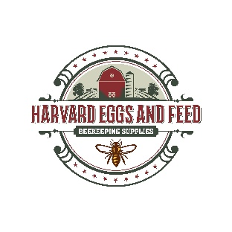
Please make a copy for your records!!

Harvard Eggs, Feed & Produce has a full line of beekeeping equipment!!
Assembled and unassembled woodenware
Frames and foundation
Feeders and supplements
Clothing and tools
Varroa treatment
Extracting equipment, jars and labels
We wish you a happy, healthy and productive year!

